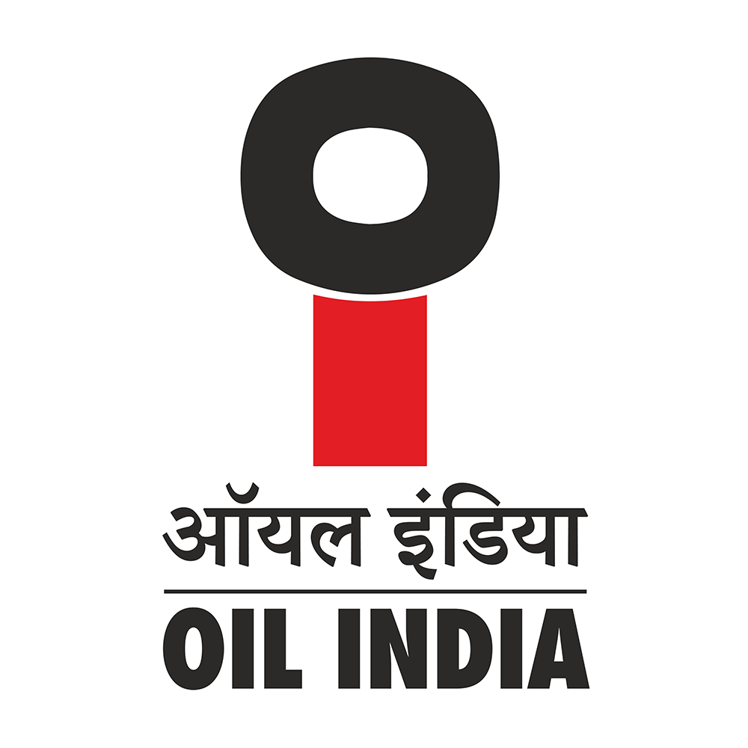
OIL INDIA LIMITED
CORPORATE OFFICE, NOIDA

OIL/PLNG/54/2/1/2026/86 27thMarch, 2026

Ministry of Petroleum and Natural Gas
Kartavya Bhawan-03, Janpath
New Delhi - 110001
Kind Attn: Mrs. Neha Pal
Section Officer (ONG-III)-Exploration Division
Sub: Rajya Sabha Provisionally Admitted Starred/Unstarred Question D. No. U7520 for 30.03.2026
Regarding “Crude oil and LNG Imports

Ref. Your email dated 18.03.2026

Madam,
Reference above, our reply to the above Rajya Sabha Question is as follows:

Q.(a) Details of crude oil imports and LNG imports in the last 10 years, year-wise, along with year-on-year change; | Answer to Q(a): MoPNG may reply suitably.  As far as Oil India is concerned, the query is not pertaining to OIL as the company is not engaged in import of Crude Oil and LNG.
Q.(b) Details of crude oil and gas production in the last 10 years, year-wise, along with year-on-year change; | Answer to Q(b): MoPNG may reply suitably.  As far as OIL is concerned, the crude oil and natural gas production in the last 10 years is as below.  Crude Oil YoY Change % Natural Gas YoY Change %  MMT MMSCM  2015-16 3.25 2838  2016-17 3.28 0.92% 2937 3.49%  2017-18 3.39 3.35% 2905 -1.09%  2018-19 3.32 -2.06% 2865 -1.38%  2019-20 3.13 -5.72% 2801 -2.23%  2020-21 2.96 -5.43% 2642 -5.68%  2021-22 3.01 1.69% 3045 15.25%  2022-23 3.18 5.65% 3180 4.43%  2023-24 3.36 5.66% 3182 0.06%  2024-25 3.46 2.98% 3252 2.20%

Q.(c) Details of crude oil reserves in India in the last 10 years, year-wise, along with year-on -year change; | Answer to Q(c): MoPNG may reply suitably.  As far as OIL is concerned, the crude oil reserves in the last 10 years is as below.  Crude Oil YoY Change % Natural Gas YoY Change % Crude Oil Reserves YoY Change %  MMT MMSCM MMT  2015-16 3.25 2838 80.74  2016-17 3.28 0.92% 2937 3.49% 78.85 -2.34%  2017-18 3.39 3.35% 2905 -1.09% 78.67 -0.23%  2018-19 3.32 -2.06% 2865 -1.38% 76.19 -3.15%  2019-20 3.13 -5.72% 2801 -2.23% 74.69 -1.97%  2020-21 2.96 -5.43% 2642 -5.68% 73.63 -1.42%  2021-22 3.01 1.69% 3045 15.25% 70.86 -3.76%  2022-23 3.18 5.65% 3180 4.43% 70.56 -0.42%  2023-24 3.36 5.66% 3182 0.06% 69.65 -1.29%  2024-25 3.46 2.98% 3252 2.20% 69.39 -0.37%
Q.(d) Details of Crude import dependence in the last 10 years, year-wise; | Answer to Q(d): MoPNG may reply suitably.  As far as OIL is concerned, the question is not pertaining to OIL.
Q.(e) Whether it is a fact that crude production of oil PSUs and private sector projects are under-performing, as per Ministry’s monthly production reports;if so, details of such problems being faced by the industry? | Answer to Q(e): MoPNG may reply suitably.  As far as Oil India Limited (OIL) is concerned, the company has witnessed sustained increase in production of crude oil and natural gas from matured fields. The table appended below shows the production of crude oil and natural gas since 2020-21  Parameters UoM 2020-21 2021-22 2022-23 2023-24 2024-25  Crude Oil MMT 2.964 3.010 3.176 3.359 3.458  Natural Gas BCM 2.642 3.045 3.180 3.182 3.252  From the table, it can be seen that there is a 16.67% increase in the production of crude oil from FY2020-21. Similarly, there is an increase of around 23% in the production of Natural Gas during the same period

Yours faithfully,
OIL INDIA LIMITED

(Ashim Kumar Bharali)
General Manager (Planning)
For Chief General Manager (Planning)
For Chairman & Managing Director

